# Atmel Danza Board HW Change

* The Atmel board can only output clock on EXT2 and EXT3 so the Danza will plug in EXT2
* Next you will need to short PB15 and PB13 on the Atmel board or pins 8 and 10 on the Danza board in order for the clock to go to P0 on IA611

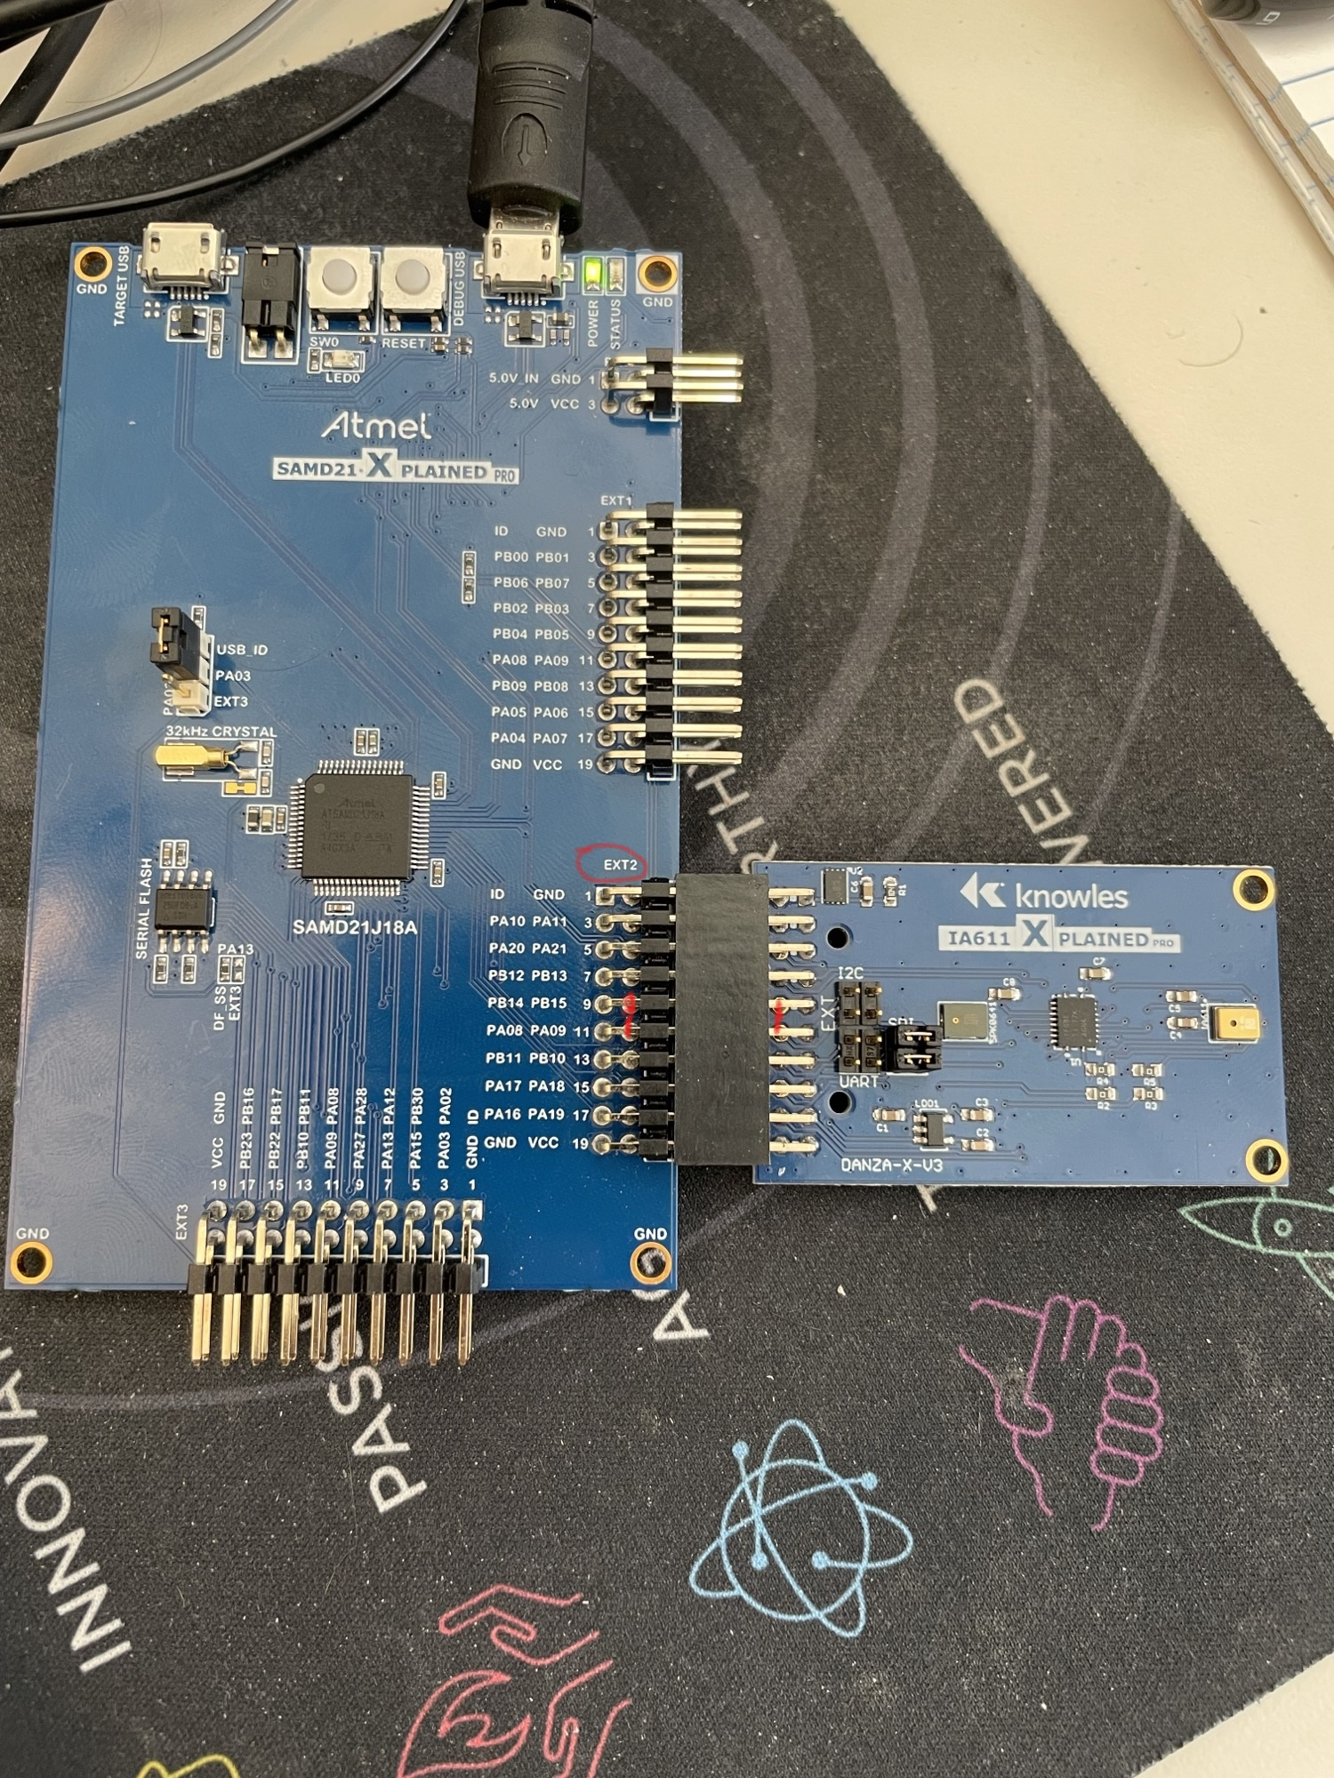

# Clock and SPI changes

* In the provided conf_clocks.h file, copy and paste all of the code over the current conf_clocks.h file. This will overwrite with the output clock at 3.072M
* The function config_outClk() will enable the output clock on PB15. I have this defined in main.c
* Lastly, copy and paste the IA61x_samd21_VQ_spi.h file and overwrite the existing. This will change the SPI output to EXT2 instead of EXT1

static void config_outClk(void)

{

struct system_pinmux_config mux_conf;

system_pinmux_get_config_defaults(&mux_conf);

mux_conf.mux_position = PINMUX_PB15H_GCLK_IO1;

mux_conf.direction = SYSTEM_PINMUX_PIN_DIR_OUTPUT;

system_pinmux_pin_set_config(PIN_PB15H_GCLK_IO1, &mux_conf);

}

// Call this function to start the output clock on PB15